Hybrid Cloud-Edge Augmented Reality System for Real-Time 360° Vehicular Awareness

Tej Singh  Master of Science in Applied Artificial Intelligence  Shiley Marcos School of Engineering / University of San Diego  tejbahadursingh@sandiego.edu | Deepti Pamula  Master of Science in Applied Artificial Intelligence  Shiley Marcos School of Engineering / University of San Diego  lpamula@sandiego.edu | Victor Salcedo  Master of Science in Applied Artificial Intelligence  Shiley Marcos School of Engineering / University of San Diego  vsalcedo@sandiego.edu | Sunitha Kosireddy  Master of Science in Applied Artificial Intelligence  Shiley Marcos School of Engineering / University of San Diego  skosireddy@sandiego.edu

GENERAL WRITING GUIDELINES
DELETE THIS SECTION BEFORE FINAL SUBMISSION
This report should be written in a formal style, similar to an academic article or a professional white paper. You should write for an audience of semi-technical stakeholders, such as a VP of engineering or a CTO. You can assume some technical knowledge, but keep the details at a level that would be interesting to this group. For example, in describing your model architecture, you should give details about the number of hidden layers, nodes, and activation functions used, but not the specific lines of code or names of function calls used to build it.
Under each section of this template, and in the weekly assignment instructions in Canvas, you will find a list of questions that are meant to guide you in terms of what information should be included in each section. DO NOT SUBMIT A LIST OF QUESTIONS AND ANSWERS. A reader should be able to answer these questions after reading your text if they are relevant to your project; they do not need to be answered explicitly, and you should avoid repeating information in your report just for the sake of answering each question independently.
A selection of formatting examples can be found in Section 7 of this document. Please refer to these examples for the proper way to include figures, tables, equations, and in-text citations, along with other general formatting guidelines.

ABSTRACT
The abstract should be the last piece of your report that you write and will be a 1-2 paragraph overview of your entire project. As a rough guide, you should expect to have 1-2 sentences introducing the problem and your chosen dataset, 3-4 sentences describing your chosen methods, and 1-2 sentences summarizing your project results.
The abstract should be the last piece of your report that you write and will be a 1-2 paragraph overview of your entire project. As a rough guide, you should expect to have 1-2 sentences introducing the problem and your chosen dataset, 3-4 sentences describing your chosen methods, and 1-2 sentences summarizing your project results.
OmniView AI addresses a critical safety problem in modern vehicles: despite widespread adoption of cameras and driver-assistance features, blind spot-related collisions remain common because existing systems do not provide complete environmental awareness or intelligently prioritize the hazards that matter most. This project asks whether a hybrid cloud and edge artificial intelligence architecture can provide real-time, 360-degree object and road sign detection with low enough latency to be genuinely useful as a driver safety tool.
The proposed solution utilizes a YOLOv8-based object detection model (Jocher et al., 2023) for traffic signal detection alongside a pretrained YOLO model for general object detection, deployed within a modular NVIDIA DeepStream pipeline (NVIDIA, 2023) on an NVIDIA Jetson edge device. A tiered blind spot alert system, a camera-based velocity tracker that estimates the relative speed of nearby objects from frame-to-frame bounding box movement, and a heads-up display overlay work together to surface the most safety-critical information to the driver in real time. The full-dataset model achieved meaningful improvements in mean average precision over a class-imbalanced baseline, and the complete pipeline sustained real-time inference rates on the edge device, supporting the hypothesis that a distributed hybrid architecture can deliver meaningful safety gains within realistic automotive deployment constraints.

KEYWORDS
Insert Applicable Keywords Here. Insert Applicable Keywords Here.
Object Detection, YOLOv8, NVIDIA Jetson, Deepstream, Traffic sign, Blind spot, Bounding box, Augmented reality, HUD

1 Introduction
OmniView AI addresses a critical safety problem of vehicle blind spots and limited driver situational awareness. Even with the latest advancements in driver-assistance technologies, many accidents continue to occur due to drivers being unable to perceive hazards and road signs outside their field of view. OmniView AI seeks to answer whether a hybrid cloud/edge artificial intelligence architecture can provide real-time 360-degree object and road sign detection with low enough latency to enhance driver safety. The core challenge is balancing the computational demands of high-accuracy AI inference against the strict timing requirements of a system that must alert a driver before a collision occurs.
This project is important because blind spot related collisions are common in modern vehicles equipped with sensors and cameras. Traditional mirror systems and standard alerts do not provide full environmental awareness and fail to prioritize threats effectively. OmniView AI introduces a smarter awareness layer that processes multi-camera inputs, identifies the objects most likely to pose immediate risk, and highlights them in real time through an augmented reality interface. By building this system on a scalable hybrid architecture—where time-critical inference runs locally on the vehicle and heavier analytics are handled in the cloud—the project also creates a pathway for continuous model improvement without requiring physical access to the vehicle.
The end user of OmniView AI is the everyday vehicle driver who seeks enhanced situational awareness and improved safety. This includes urban commuters, rideshare drivers, commercial fleet operators, and automotive manufacturers interested in integrating augmented reality-based safety systems. Ultimately, the system is designed to function as a real-time driver assistance tool that delivers visual alerts through augmented-reality (AR) glasses or a heads-up display, supporting safer decision-making during complex driving situations without requiring the driver to look away from the road.
The project draws on several established driving datasets for training and evaluation. The LISA Traffic Sign Dataset (Møgelmose et al., 2012) provides annotated traffic sign images captured from vehicle-mounted cameras under real-world conditions. The Berkeley DeepDrive (BDD100K) dataset and the KITTI Vision Benchmark Suite contribute additional annotated driving scenes with labeled vehicles and pedestrians across diverse weather and lighting scenarios. Pretrained model weights derived from the Microsoft COCO dataset (Lin et al., 2014) support transfer learning for the general object detection component. In a live production deployment, all of this data would originate from camera arrays mounted on the vehicle itself, with safety-critical inferences generated immediately on the vehicle and supplementary data streamed to cloud infrastructure for logging and model retraining.
The goal of OmniView AI is to design and validate a hybrid cloud/edge augmented reality system capable of delivering real-time 360-degree vehicle awareness. The final product combines a fine-tuned traffic sign detector, a general object detector for vehicles and pedestrians, a tiered blind spot alert module, and a velocity tracker that estimates whether nearby objects are approaching or receding—all rendered as a unified augmented reality overlay for the driver. The hypothesis guiding this work is that distributing the workload between edge and cloud, rather than relying on either alone, is the right architectural choice for achieving this combination of performance and scalability.

2 Data Summary
The dataset used in this project is the LISA Traffic Sign Dataset (Møgelmose et al., 2012), which contains images captured from a vehicle-mounted camera in real-world driving environments. Each image contains one or more traffic signs annotated with bounding boxes and class labels. The primary variables present in the dataset span four categories: image frames, traffic sign categories, bounding box coordinates, and implicit image metadata.
Each observation consists of a digital image frame captured from a forward-facing vehicle camera containing road scenes with traffic signs appearing at different distances, angles, lighting conditions, and levels of occlusion. Each labeled object is assigned to one of seven traffic sign categories used in this project: Go, Go Forward, Go Left, Stop, Stop Left, Warning, and Warning Left. These categories span the range of regulatory and warning signs most relevant to active driving decisions. Although not used directly as model inputs, each image also implicitly encodes environmental information such as lighting conditions, object distance, background complexity, and camera angle—all of which introduce the kind of real-world variability that a robust detection model must be able to handle.
Several challenges were identified during exploratory analysis of the dataset. One of the primary issues was class imbalance, where certain traffic sign classes such as Stop and Go appeared significantly more frequently than others, while rare classes such as Go Forward and Warning Left had very limited representation. As shown in Figure 1.1, Stop and Go have substantially higher occurrence counts than the remaining categories. This imbalance can bias the model toward dominant classes and reduce performance on underrepresented categories that may nonetheless be safety-critical.

Fig 1.1
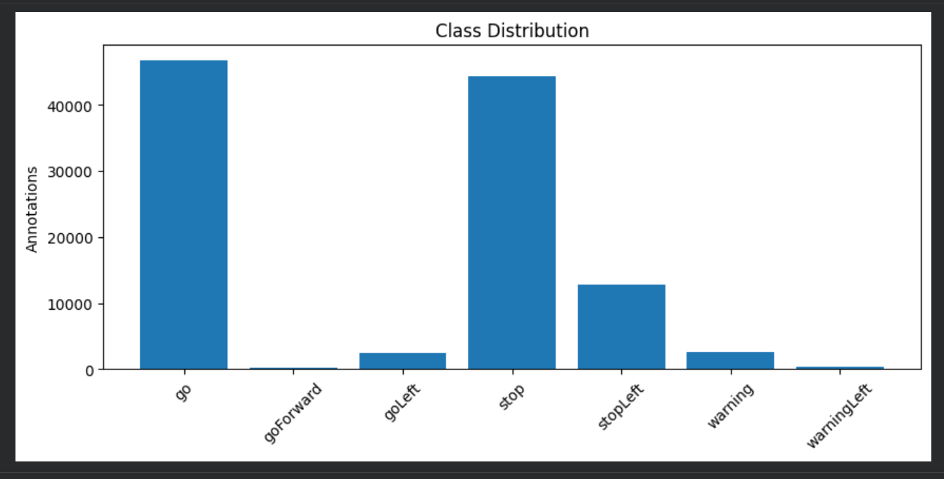
Another important consideration was dataset scale and diversity. Early experiments conducted on a smaller subset of approximately 500 images resulted in overly optimistic performance due to limited variation in the training examples—a classic sign of overfitting. Expanding the dataset to over 30,000 images significantly improved diversity and reduced the risk of overfitting. As shown in Figure 1.2, most images contain between two and four annotated objects, indicating moderate scene complexity typical of real driving environments.
Fig 1.2
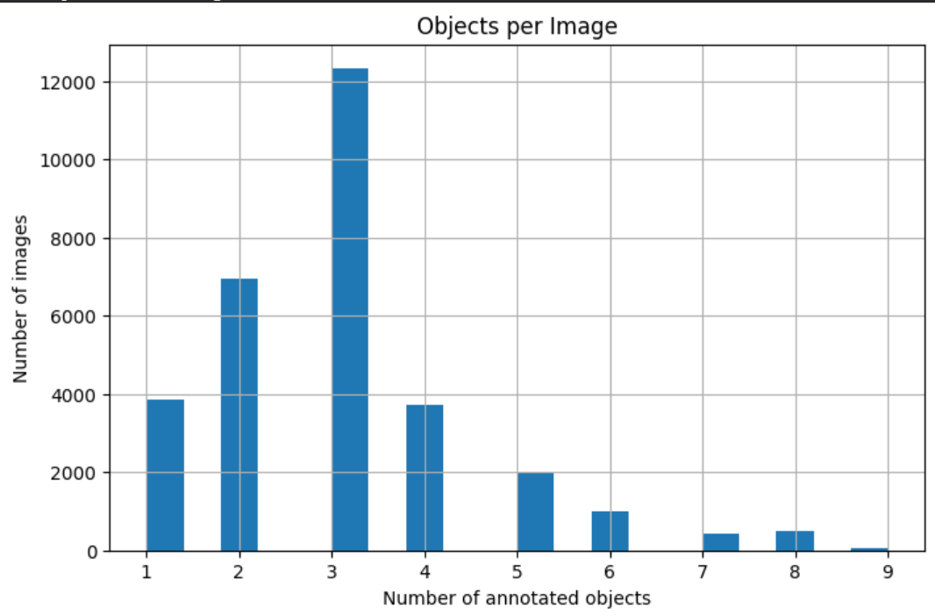
The dataset also exhibits substantial variability in real-world conditions, including differences in lighting, object distance, occlusions, motion blur, and perspective distortion. These factors increase detection complexity but also improve the model’s robustness when handled appropriately. To address these challenges and improve generalization, data augmentation techniques were applied during training, including random scaling, horizontal flipping, color space adjustments using HSV augmentation, and mosaic augmentation. Figure 1.3 shows representative output after applying these techniques.
Fig 1.3
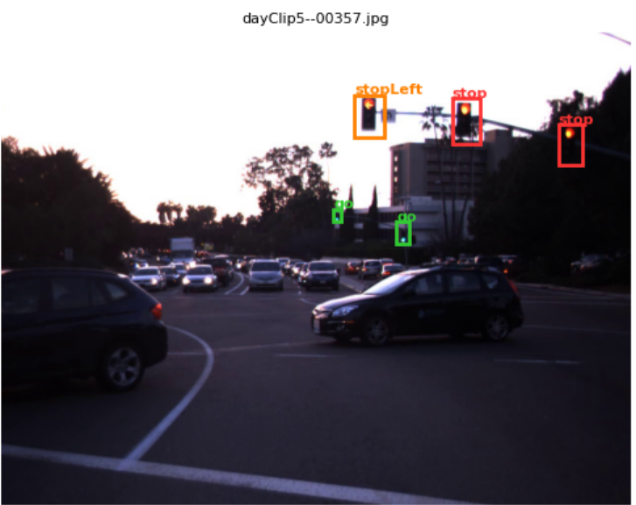
The goal of the project is to develop a real-time traffic sign and blind spot detection system capable of identifying and localizing traffic signs and blind spots in video streams from a vehicle-mounted camera. The dataset variables directly support this objective: image frames serve as the input data for the detection model, bounding box coordinates provide supervision for object localization, and traffic sign categories serve as classification labels that allow the model to distinguish between different types of signs.
Exploratory analysis revealed several patterns in the dataset. Larger traffic signs that appear closer to the camera are generally easier for the model to detect, while smaller and more distant signs present greater challenges. Additionally, rare classes are more likely to be underrepresented in predictions if not explicitly addressed during training. These observations informed the use of oversampling and augmentation strategies described in the Methodology section.
Relationships between variables also play an important role in model performance. Classes with higher frequency in the dataset tend to achieve better detection accuracy, as the model has more examples to learn from. In contrast, rare classes are more difficult to detect due to limited training data, even after oversampling.
Bounding box size is another important factor influencing detection performance. Larger bounding boxes typically correspond to nearby objects and are easier to detect, while smaller bounding boxes represent distant objects that are more challenging for the model. This relationship affects how the model learns spatial features across different scales.

3 Literature Review
Real-time perception of road environments is a critical component of autonomous driving platforms. These systems must accurately detect and classify objects such as vehicles, pedestrians, and traffic signals from continuous video streams captured by vehicle-mounted cameras. Reliable detection enables applications such as collision avoidance, blind spot monitoring, and traffic signal awareness—and, as extended in OmniView AI, relative velocity estimation for approaching hazards.
Object detection in road environments has been extensively studied, with modern approaches increasingly emphasizing real-time performance for applications such as autonomous driving and advanced driver assistance systems. YOLO (You Only Look Once) has emerged as one of the most widely adopted object detection frameworks due to its ability to perform object localization and classification in a single forward pass, enabling high-speed inference while maintaining competitive accuracy (Redmon et al., 2016). Its architecture, which combines feature extraction, multi-scale representation, and detection into a unified model, makes it particularly well-suited for dynamic driving scenarios where objects appear at varying distances and scales. The architecture has continued to evolve, with YOLOv8 (Jocher et al., 2023) introducing improvements in feature extraction and detection head design that lead to better performance on both large and small objects within the same scene.
In parallel, NVIDIA DeepStream has been developed as a high-performance streaming analytics platform that enables efficient deployment of deep learning models on edge devices such as Jetson systems. DeepStream integrates video ingestion, inference, and visualization into a unified pipeline, allowing multiple models to run in parallel and process live video streams with low latency (NVIDIA, 2023). Together, YOLO-based detection models and DeepStream deployment frameworks form the foundation of many real-time perception systems used in modern intelligent transportation and edge-based vision applications.
In real-time applications, many systems adopt a modular multi-model approach rather than relying on a single unified detector. Autonomous driving systems often use one model for general object detection and another specialized model for traffic signals or signs. This modular design improves performance because each model can be trained on a dataset specifically tailored to its task. Camera-based velocity estimation—deriving whether nearby objects are approaching or receding from frame-to-frame changes in their apparent size and position—has also been explored as a low-cost complement to radar and lidar in automotive perception systems (Fathiazar et al., 2023), and forms the basis of the velocity tracker integrated into OmniView AI.
Traffic signal detection presents unique challenges due to small object size, varying lighting conditions, and signal state classification. Datasets such as the LISA Traffic Sign Dataset (Møgelmose et al., 2012) have been developed specifically to address this problem by providing annotated traffic signal states in real-world driving conditions. Research using LISA and similar domain-specific datasets has consistently shown that models trained on targeted, in-domain data outperform those relying on general-purpose datasets for fine-grained traffic sign classification.
Class imbalance is a well-known challenge in object detection tasks, particularly when certain classes appear far less frequently than others. Prior research has explored several techniques to address this issue, including oversampling underrepresented classes, applying data augmentation, and using weighted loss functions to reduce bias toward dominant classes (Vargas et al., 2023; Kishanthan & Hevapathige, 2025). These approaches have been shown to improve detection performance for rare classes while maintaining overall model accuracy.
In addition to class imbalance, variability in real-world data presents further challenges for detection models. Data augmentation techniques such as scaling, horizontal flipping, color adjustments, and mosaic augmentation are commonly used to improve robustness under varying environmental conditions (Shorten & Khoshgoftaar, 2019; Lee et al., 2023). These methods help models generalize better to differences in lighting, object scale, and perspective. Augmented reality heads-up displays have also been studied as a mechanism for directing driver attention toward detected hazards without inducing cognitive overload, which motivated the display design used in OmniView AI (Fathiazar et al., 2023).
Several real-world and research systems use similar approaches. Autonomous driving perception systems use YOLO or similar detectors for real-time object detection. Blind spot detection systems rely on vehicle detection models trained on datasets like COCO or BDD100K. Traffic signal recognition systems use specialized datasets like LISA to classify signal states. These systems often combine multiple detection models and ancillary modules into a single pipeline, demonstrating the effectiveness of a modular approach for complex perception tasks.

4 Methodology
Model Architecture and System Design
The system uses a YOLOv8-based object detection model for traffic signal detection, combined with a modular multi-model architecture for real-time perception (Jocher et al., 2023; Redmon et al., 2016). YOLOv8 is a one-stage detection model that performs object localization and classification in a single forward pass, meaning it produces both bounding boxes and class predictions simultaneously rather than in separate stages—making it well suited for real-time applications where low inference latency is critical (Jocher et al., 2023; Yaseen, 2024). The architecture uses a layered feature extraction backbone that captures image details at multiple scales, allowing it to detect both nearby objects that occupy a large portion of the frame and distant objects that appear much smaller—a critical property in driving environments where the same type of hazard may appear at many different distances simultaneously (Jocher et al., 2023; Yaseen, 2024).
In addition to the traffic signal detection model, a separate pretrained YOLOv8n model trained on the Microsoft COCO dataset (Lin et al., 2014), which contains 80 object categories across 330,000 images, was deployed in parallel for general object detection including vehicles and pedestrians. Separating these two detection tasks into specialized models—rather than attempting to handle all categories with a single generalized model—allows each to be trained and optimized for its specific domain, which prior research has shown to improve detection performance for fine-grained categories such as traffic sign states (Jocher et al., 2023; Yaseen, 2024). Both models are deployed within the NVIDIA DeepStream framework (NVIDIA, 2023), which provides the infrastructure for running multiple AI models in parallel on embedded GPU hardware and merging their outputs into a unified perception layer.

Training Procedure and Pipeline
The traffic signal detection model was trained using the LISA Traffic Sign Dataset (Møgelmose et al., 2012), which contains annotated traffic signal states captured from vehicle-mounted cameras in real-world driving conditions. The dataset was preprocessed and converted into YOLO format, and then split into training and validation sets to support model evaluation during training (Jocher et al., 2023; Møgelmose et al., 2012).
To improve generalization, data augmentation techniques were applied during training, including scaling, horizontal flipping, color space adjustments using HSV augmentation, and mosaic augmentation, which composites four images into a single training sample (Jocher et al., 2023; Lee et al., 2023). These transformations introduce variability in object appearance and positioning, helping the model learn robust feature representations that generalize to real-world variability in lighting, object scale, and perspective (Shorten & Khoshgoftaar, 2019; Lee et al., 2023).
The initial training phase was conducted on a subset of 500 images using 100 epochs, a batch size of 64, an image size of 640, and a learning rate of 0.01. This setup provided a baseline model but was limited by the class imbalance inherent in the smaller subset (Møgelmose et al., 2012). The model was subsequently fine-tuned using the full dataset after applying an oversampling strategy to address class imbalance. The final training configuration used 50 epochs, a batch size of 64, an image size of 640, and a reduced learning rate of 0.001 to support stable convergence across all classes (Jocher et al., 2023). The model was trained using standard YOLO loss functions, which combine bounding box regression, classification, and distribution focal loss components to jointly optimize localization and classification performance (Jocher et al., 2023; Yaseen, 2024).

Handling Class Imbalance
The LISA dataset exhibits significant class imbalance, with stop and go classes appearing far more frequently than goLeft, warningLeft, and stopLeft (Møgelmose et al., 2012). When a model is trained on such an imbalanced distribution, it tends to concentrate its predictive capacity on the categories it sees most often, achieving strong performance on dominant classes at the expense of rare ones—a pattern well documented in the object detection literature (Vargas et al., 2023; Kishanthan & Hevapathige, 2025). To address this, oversampling was applied to images containing underrepresented classes, increasing the frequency of rare classes during training and allowing the model to learn more balanced representations across all categories (Vargas et al., 2023; Kishanthan & Hevapathige, 2025).

Model Optimization
During model optimization, several hyperparameters were explored to improve training stability and model performance, including the number of training epochs, batch size, learning rate, and data augmentation parameters (Jocher et al., 2023; Yaseen, 2024). Augmentation-related parameters such as scaling, translation, and color adjustments were tuned to better reflect real-world variability in driving environments, following established practices for YOLO-based detection pipelines (Jocher et al., 2023; Lee et al., 2023). Training duration was adjusted to balance convergence and overfitting, with early stopping mechanisms used to prevent unnecessary training beyond convergence (Jocher et al., 2023). The final model configuration reflects a balance between training efficiency and generalization capability suited to the constraints of real-time edge deployment.

Deployment Pipeline
For deployment, the system is designed to run on an NVIDIA Jetson edge device using the NVIDIA DeepStream SDK (NVIDIA, 2023), which provides a hardware-accelerated framework for running deep learning models in real time on embedded GPU hardware. The trained YOLOv8 traffic signal detection model was exported to a standard interchange format and converted to an optimized inference engine using half-precision numerical representation, which reduces memory usage and accelerates computation with negligible impact on detection accuracy (Jeong et al., 2022; Shi et al., 2022).
Both models operate on the same video input stream and perform inference simultaneously within the DeepStream pipeline. The detection outputs from each model are combined into a unified perception layer and rendered through a single heads-up display that overlays bounding boxes, class labels, and confidence scores onto the video stream, enabling real-time visualization of both traffic signals and surrounding objects (NVIDIA, 2023; Fathiazar et al., 2023). This deployment approach enables low-latency inference on edge hardware and supports modular scalability, allowing additional detection models to be incorporated into the system as needed.

DeepStream Inference Pipeline
The inference pipeline was implemented using NVIDIA DeepStream SDK 7.0 (NVIDIA, 2023), a streaming analytics framework that provides hardware-accelerated components for video ingestion, decoding, inference, and visualization on NVIDIA GPU hardware. Both trained YOLOv8 models were converted to optimized inference engines using half-precision quantization, which reduces memory footprint and increases throughput without significant loss in detection accuracy (Jeong et al., 2022; Shi et al., 2022). The pipeline processes video input through a sequential chain of components: video is decoded and batched, passed first to the traffic sign inference stage, then to the general object detection stage, and finally to the display component for bounding box rendering. Detection metadata is extracted at each inference stage and made available for downstream processing without interrupting the pipeline’s real-time flow (NVIDIA, 2023).

Blind Spot Detection Logic
Blind spot zones were defined geometrically as regions covering the lower 52% of the frame height and the outermost 22% of the frame width on each side, corresponding to the peripheral areas of a forward-facing vehicle camera where lane-adjacent hazards are most likely to appear. When a detected vehicle or pedestrian falls within one of these zones, an alert is triggered. Alert severity is tiered by detection confidence: objects detected with moderate confidence produce a yellow visual indicator, while high-confidence detections trigger a red alert, communicating both the presence and certainty of the hazard to the driver (Jocher et al., 2023; Yaseen, 2024). A minimum confidence threshold is applied across all general object detections to suppress spurious alerts from low-confidence, distant, or partially obscured objects.

Metadata Output and HUD Integration
Per-frame detection results from both models are packaged into structured data payloads and transmitted to the augmented reality heads-up display module, which renders bounding boxes, class labels, confidence scores, blind spot zone indicators, and relative velocity annotations as overlays on the live camera feed (NVIDIA, 2023). Each payload includes a timestamp, frame sequence number, and per-detection records containing the class label, confidence score, bounding box coordinates, blind spot zone assignment, originating model identifier, and estimated relative velocity from the velocity tracker. Coordinates are expressed relative to frame dimensions to allow the display to render correctly regardless of camera resolution, which is important for supporting different vehicle configurations (Fathiazar et al., 2023; NVIDIA, 2023). The velocity tracker estimates the relative speed of each detected object by measuring how the center of its bounding box moves between successive video frames, applying a smoothing filter over multiple frames to reduce noise inherent in frame-to-frame bounding box comparisons. Although camera-based velocity estimation cannot achieve the precision of dedicated ranging sensors, it provides meaningful ordinal motion cues—distinguishing closing, static, and receding objects—without requiring any additional hardware beyond the cameras already in the system (Fathiazar et al., 2023).

Jetson Deployment
For edge deployment, the pipeline was adapted for the NVIDIA Jetson Orin Nano, a compact embedded computing platform with an integrated GPU designed for real-time AI inference workloads (Jeong et al., 2022; NVIDIA, 2023). The trained models were converted to device-specific optimized inference engines directly on the hardware, as these engines are architecture-specific and cannot be transferred across GPU platforms (Jeong et al., 2022; Shi et al., 2022). The pipeline was modified to accept live video input from a camera module mounted on the vehicle, replacing the pre-recorded video files used during development, to support real-time inference from a vehicle-mounted camera during drive testing (NVIDIA, 2023). Tej Singh led the Jetson integration effort, adapting the development pipeline for the embedded hardware and validating live inference performance under real driving conditions.

5 Results
This section of your final report should describe how your model/system performed and provide evidence for how your work did or did not support your experimental hypothesis or solve your chosen problem. The reader should be able to answer the following questions:
- How effective was your machine learning model at learning the task? e.g. Did the model overfit/underfit the training data? What does the training accuracy/loss curve look like for your model?
- If your project is focused on answering a research question, what evidence do you have to support or disprove your hypothesis?
- If your project is focused on solving a problem, how will your model performance affect the application of your model to that problem?
- If your project is focused on implementing a complete machine learning system, what is the user experience? Are there any delays or remaining bugs that affect your model output either in common or edge use cases?

6 Conclusion
This section of your final report should provide a very brief summary of your entire project. It should highlight the most interesting or significant results and discuss any future work that you or another researcher might do. The reader should be able to answer the following questions:
- What was the main hypothesis or goal of the project, and how did your models perform in relation to this hypothesis/goal?
- What was the most interesting or significant result of your project?
- Did your model training or performance bring about any unexpected results?
- If you were to continue this project, what would your next steps be? For example, would you continue to optimize your model or try other model architectures? Would you change or expand the data used in your model? What steps need to be taken to “productionize” your model?

7 FORMATTING EXAMPLES
DELETE THIS SECTION BEFORE FINAL SUBMISSION

7.1 General Formatting
A formal report of this type should be primarily in paragraph form, with minimal subheadings, bullet points, or numbered lists. For most of your required report sections, no subheadings will be necessary, and the information can be presented as a single, cohesive discussion of the content relevant to that section. As a general rule of thumb, bulleted or numbered lists are only appropriate in this kind of report if the list items are less than one sentence, but are too long/detailed to be presented in a table.
If you feel strongly that your content would benefit from subheadings or bulleted/numbered lists, they should follow the formatting examples used in this section.

7.2 In-text Citations
A report of this type should be heavily supported by in-text citations. You should include a new supporting citation in each section for:
- The first time that you mention a specific code library or dataset,
- The first time that you introduce a pre-trained model or model architecture,
- Any information that is not your own original thought/idea, even if you didn't need to look it up.
When in doubt, it is always better to over-cite than to under-cite.
Formatting rules for in-text citations can be found in the APA guidelines, but examples of the three most common uses are discussed in the following paragraphs.
Parenthetical citations at the end of a sentence should be used when the information from the entire sentence comes from the cited source (American Psychological Association, 2025).
Parenthetical citations mid-sentence should be used when only a part of the sentence comes from the cited source, or when you are providing a citation for something specific such as a company, model architecture/method, or technique. See the following examples for a sentence with multiple mid-sentence citations and a sentence with a specific mid-sentence citation below:
- The transformer model was introduced in 2017 for the application of machine translation (Vaswani et al., 2017) and quickly became the most common backbone for today’s large language models (Devlin et al., 2019; Radford et al., 2019).
- As one of the first transformer-based generative text models, OpenAI’s GPT (Radford et al., 2019) quickly became the standard large language architecture used for generative tasks.

Narrative in-text citations can be used when you want to include the name of the author(s) in your main text, as shown in the following example:
Vaswani et al. (2017) originally developed the transformer architecture for the application of machine translation.

7.3 Figures, Tables, and Equations
Most of your supporting content should be included in the main text of the report, rather than at the end. While the in-line formatting can be a headache, this makes it easier for your reader to reference your figures and tables while reading, without having to scroll back and forth too much. See Section 7.5 for more details about how to properly use appendices for supplemental information.

7.3.1 Figures
Figures should be numbered sequentially below the image and referred to directly in your text (e.g. “As seen in Figure 7.1 [...]”, “Figure 7.1 shows [...]”). If your figure is important enough to include in your report, then it deserves at least one sentence of discussion in the text.
Each figure should also have a corresponding caption that briefly describes the content of the figure and can be used to highlight important details. If your figure is too complex to be limited to a single column width, you can include it as a full-width image at the top of the page.
Figure 7.1
Example text: Model accuracy for our six models during training. The best performing model is shown in red.

7.3.2 Tables
Tables should be numbered sequentially above the table and should have an in-text mention and a descriptive caption, like the figure examples given above.
Feel free to improve the default MS Word table formatting shown here for aesthetic appeal (e.g. change cell size, border width, font size, etc.). If you have a favorite table formatting tool (e.g. LaTeX, Pandas pretty print, etc.), feel free to use that and include the output as an image. However, please ensure that the image quality is legible and the formatting generally matches the rest of the report, and DO NOT include screenshots of raw code output—it is not professional to include dark mode or Courier New code output, or screenshots of your console window.
Table 7.1
Example text: Results for all three models over the standard benchmarking metrics. Highlighted cells show the best performance for each metric.

A table is often a better alternative to a bulleted list for communicating information that may otherwise seem redundant (e.g. variable details or model hyperparameter choices), or to make information easier to compare across categories (e.g. model performance). If you have a very complex table, think about how you might use bold or italic font to highlight notable cells, such as the best performing model.

7.3.3 Equations
Think carefully about whether including an equation is appropriate for your semi-technical stakeholder audience—most of the time that level of detail will be too technical, and equations should either be left out or included in a separate appendix.
If you decide that you do want to include an equation, they should be on a separate line, indented, and numbered sequentially to the right of the equation. As with figures and tables, equations should be referenced directly in your text with a short description (e.g. “Equation 7.1 shows the basic linear regression equation, where y is the target variable, x is the model input, a is the learned coefficent, and b is the model intercept.”) You DO NOT need to include a separate caption for your equations.
$y=ax+b$ (7.1)
As with tables, if you have a favorite tool for formatting your equations, feel free to include the formatted equation as an image, as long as it matches the formatting shown in the example above.

7.4 Works Cited
References should be alphabetically ordered using APA 7 formatting. You can refer to the APA guidelines on how to format citations from different types of sources. There are also online tools that can be used to create citations for you, though these will occasionally produce errors, so be sure to double check these. If you are citing an academic paper, the Google Scholar listing for the paper will also have a properly formatted APA citation that you can copy into your report. Several example citations are shown in the works cited included in this template.

7.5 Appendices
Appendices can be used to include information that you feel is important to the communication of your project but may be too technical or too detailed for the intended semi-technical stakeholder audience. This may include items like a detailed description of data transformations, feature engineering, or architectural choices, or complete results over a hyperparameter grid search or a series of experimental architectures.
Appendices are not included in the page count but should not be used to get around the report page limits. Information included in the appendices should not be necessary for a basic understanding of your project and should instead provide deeper detail for an interested reader. You can assume that your stakeholder audience would not read most of the content in an appendix, and as such, your appendix content may not contribute to your final report grade.
Appendices should be labeled alphabetically (Appendix A, Appendix B, etc.) and should be referred to directly in your text (e.g. “A complete table of results over all hyperparameters can be found in Appendix A”). Each appendix should start on a new page and does not need to be in the two-column format if full page width makes more sense for your content (e.g. detailed figures or large tables).

ACKNOWLEDGMENTS
These are optional, but might mention any external contributors to your project, such as professors or mentors who provided data or consultation.
Works Cited
American Psychological Association. (2025). In-Text Citations. https://apastyle.apa.org/style-grammar-guidelines/citations
Devlin, J., Chang, M. W., Lee, K., & Toutanova, K. (2019, June). Bert: Pre-training of deep bidirectional transformers for language understanding. In Proceedings of the 2019 conference of the North American chapter of the association for computational linguistics: human language technologies, volume 1 (long and short papers) (pp. 4171-4186).
Radford, A., Wu, J., Child, R., Luan, D., Amodei, D., & Sutskever, I. (2019). Language models are unsupervised multitask learners. OpenAI blog, 1(8), 9.
Vaswani, A., Shazeer, N., Parmar, N., Uszkoreit, J., Jones, L., Gomez, A. N., ... & Polosukhin, I. (2017). Attention is all you need. Advances in neural information processing systems, 30.

